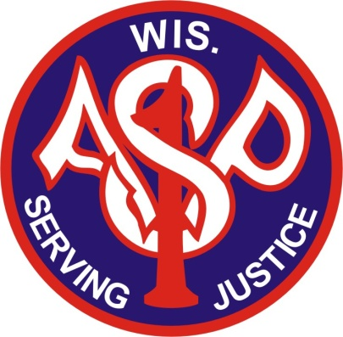
Association of
SWAT Personnel – Wisconsin Ltd.
Est. 1982
The Association of SWAT Personnel Wisconsin is running a two-day conference. This year’s conference will be March 18- March 19, 2024, at the Sheraton Milwaukee Brookfield Hotel. You can access hotel information at the following link https://www.marriott.com/en-us/hotels/mkesi-sheraton-milwaukee-brookfield-hotel/overview/

This year’s conference will be two days and will have a wide range of topics. We are again offering an opportunity to the Vendors who have supported this association in the past. We have discounted enrollment for the conference in hopes of boosting attendance. Vendor spaces will be limited so if you want to display at this year’s conference, please contact me as soon as possible.

Spaces for vendors, will be limited to tables that are 4x8. Prices are still being negotiated for the cost of the tables and electric.

As in the past, if any vendor would like to trade merchandise in lieu of the cost of each table, you should contact Mike Anderson at aspwivendor@gmail.com

The Vendor show will be advertised via constant contact E-mail blasts as well as advertisements placed in law enforcement periodicals.

The emphasis of the vendor show is to provide our vendors an opportunity to showcase their merchandise. This greater exposure will provide the support our vendors need in these tough economic times. You will be given a link from our website to yours.

If this is something your company would be interested in, fill out the attached application or contact me at aspwivendor@gmail.com

Mike Anderson
ASP Executive Board of Directors
Chairman of Marketing
Association of SWAT Personnel Wisconsin

