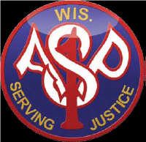 Association of SWAT Personnel-Wisconsin

2025 Annual Training Conference and Trade Show
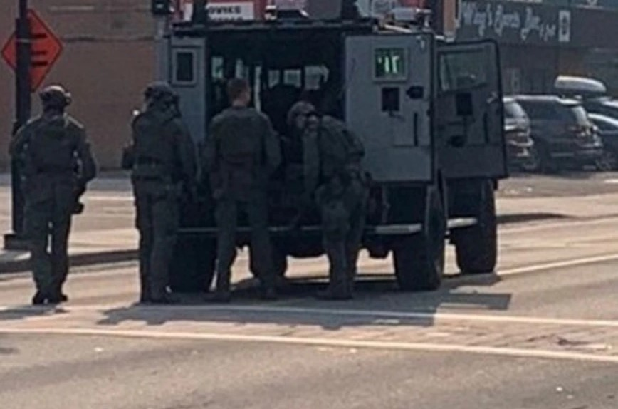

March 10-11, 2025
Sheraton Milwaukee-Brookfield
Brookfield, WI

From the President of ASP:

Greetings!

On behalf of the Executive Officers and Board of Directors of the Association of SWAT Personnel-WI, I invite you to attend our 43rd Annual Training Conference and Vendor Expo. As you will see by the conference agenda, we have another outstanding line-up of informative and detailed incident presentations from representatives from law enforcement agencies from across the United States. This conference also gives us the opportunity to network with fellow officers and continue the long-established tradition of information sharing.

Over the past 43 years, an incredible milestone for an association, ASP has consistently provided its members with the most current and trending subject matter at an affordable cost to our attendees. Our 43-year history goes back to early days of the initiation of the tactical operations concept, later more commonly to be known as SWAT. This past year has certainly been a busy year for SWAT and all law enforcement officers throughout the State. From the numerous tactical missions to the RNC in Milwaukee and the weekly to almost daily requests for tactical assists at the presidential campaign rallies throughout the State of Wisconsin. You all stepped up to missions and made it happen, keeping in the highest traditions of the SWAT and law enforcement community.

As we have mentioned in the past, attending this conference is not limited to just tactical officers. While our focus is on the tactical response to a major incident, these incidents always start with a first responder initiation. All law enforcement, EMS and appropriate law enforcement partners are welcome at our training conference. ASP will continue to offer this type of training as we move forward performing our service to the citizens we are sworn to protect.

Enjoy the conference, engage in thoughtful discussions, see old friends, and establish new ones.

Steve Pederson
President/Conference Chair


Association of SWAT Personnel-Wisconsin
Annual Training Conference
Sheraton Milwaukee Brookfield, Brookfield, WI
March 10-11, 2025

Sunday March 9, 2025

4:00PM-5:00PM Board of Directors Meeting

6:00PM-8:00PM Early Registration

Monday March 10, 2025

7:00AM Registration Opens

08:00-08:30 Opening Remarks

08:30-12:00 Incident Debrief- Multi Jurisdictional Tactical Event

Lt. Jason Meidl, Portage County Sheriff’s Office
Lt. Joe Johnson, Stevens Point Police Department
Lt. Will Stuart, Marathon County Sheriff’s Office

12:15-1300 Lunch

13:30-1600 Incident Debrief-Warrant Service/OIS/ Multi-Day
Manhunt In the Kentucky Mountains

Sergeant Heath Ayres, Kentucky State Police
Trooper Logan Smith, Kentucky State Police

Tuesday March 11, 2025

0830-11:30 Domestic Terrorism and International
Terrorism Threats, Indicators, and Trends Impacting
Wisconsin

SSA Maria Miller
IA Gwen McWilliams
IA Baylee Blake
FBI Milwaukee Division

1230-1345 Awards Luncheon

1400-1630 Leadership, Tactics, Training and Lessons Learned

Jon Becker, Host, The Debrief

Speaker Bios and Presentation Synopsis

Lt. Jason Meidl, Portage County Sheriff’s Office
Lt. Joe Johnson, Stevens Point Police Department
Lt. Will Stuart, Marathon County Sheriff’s Office

Will Stuart
Lieutenant Will Stuart of the Marathon County Sheriff’s Office brings 15 years of dedicated service to law enforcement. He has served for 11 years on Marathon County’s 32-member multi-jurisdictional SWAT Team, one of nine designated ALERT teams in the state, and currently holds the position of Team Commander.
In addition to leading the SWAT Team, Lieutenant Stuart oversees the Central Wisconsin Narcotics Task Force, a 12-member federally funded unit tasked with combating the narcotics threat in central Wisconsin. He is also a 20-year veteran of the Wisconsin Army National Guard, where he completed multiple deployments and gained extensive leadership and operational experience.
Will is a recent graduate of the FBI National Academy (Class 289) and remains actively involved in the academy's professional network.

Joe Johnson
Joe Johnson has been in law enforcement since April 2006. Joe has five years previous experience with the Monroe Police Department, and he currently serves as the administrative Lieutenant for the Stevens Point Police Department. Joe has been associated with the SWAT community for about 15 years, serving roles of Assistant Team Leader and Team Leader. Joe is starting his third year as Team Commander for the Stevens Point/Plover SWAT Team. Joe is also the department master Use of Force Instructor and the Active Shooter training coordinator for Portage County Law Enforcement, Fire, and EMS.

Jason Meidl
Lieutenant Jason Meidl has been with the Portage County Sheriff’s Office for over 18 years. He currently oversees support services for the sheriff’s office which consists of Court Security, Investigations, Evidence and Property, Training, DNR programs and Fleet. He has been a member of the Portage County Special Response team for 15 years beginning as a sniper, entry team member, Assistant Team Leader, Team Leader, and Team Commander.

~This multi day event started on July 23rd, 2024, when the suspect in this matter, Jeffrey Miller, was involved in a pursuit for a traffic violation during the late evening hours of that day. During the pursuit, spike strips were deployed and after a short distance Miller drove his vehicle into a ditch. The first officer arriving at Miller's location was fired upon immediately with 23 rounds striking the drivers area of the officers squad car. The suspect, Miller ran from the incident’s location and was not apprehended.

On July 25th, 2024, Sauk County Sheriff’s Office investigators conducted interviews and follow up investigation and determined that Miller was located at a residential address in Amherst WI. This residence was well known to law enforcement having a history of gang activity, with anti-law enforcement and anti-government postures in place. With that history, Steven's Point SWAT, Marathon County SWAT, and Portage County SRT were activated to take Miller into custody. On that initial activation specialized drone and bomb technician teams were also activated from Marathon County.
As this event plays out it called upon tactical operators and commanders to genuinely think out-of-the-box as this developed into a multi-jurisdictional and complex tactical situation. Tactical Elements not only were subjected to rounds fired from within the residence at them, it also resulted with SWAT using all the tools and assets available to end the situation. Not only were the tactical elements listed above deployed, but as the situation continued, tactical support was requested from the Waupaca County Sheriff's Office, Wood County Sheriff's Office, Wisconsin Rapids SWAT, and Marshfield SWAT. In addition, Winnebago County, Sheboygan County, UW Madison, and Madison Police departments all responded with their drone teams to assist.

This presentation exemplifies law enforcement agencies and tactical teams working together to bring a very volatile and violent situation to an end.

Supervisory Special Agent Maria Miller-FBI Milwaukee
Intelligence Analyst Baylee Blake-FBI Milwaukee
Intelligence Analyst Gwen McWilliams-FBI Milwaukee

SSA Maria Miller
Maria Miller is a Supervisory Special Agent (SSA) with the FBI in Milwaukee, overseeing Counterterrorism investigations in Southeast Wisconsin. In addition to international and domestic terrorism, she also supervises the FBI's Weapons of Mass Destruction and Behavioral Analysis Unit (BAU) programs for the state. SSA Miller previously served as the Threat Management Coordinator, connecting key stakeholders in threat cases, providing research-backed training to local partners, and referring cases to the FBI's BAU. She also served as the Tactical Operations Center Coordinator for 7 years, directing communications between FBI SWAT, crisis negotiators, and executive management during high-risk warrants and critical incidents. SSA Miller has been a Special Agent with the FBI for 10 years and has a Doctorate in Criminal Justice from Indiana University.

IA Baylee Blake

Intelligence Analyst Baylee Blake has over 6 years of law enforcement experience with a background in victim advocacy, dispatch, probation, and private security. She has a master’s degree in law enforcement Intelligence and Analysis where she spent most of her graduate work evaluating lone wolf terrorism in the United States. Baylee joined the FBI in 2023 working international terrorism matters.

IA Gwen McWilliams

Gwendalyn McWilliams became an Intelligence Analyst at the Federal Bureau of Investigation in 2019. Assigned to the Milwaukee Field Office, she has worked the Domestic Terrorism threat since late 2020 and previously worked Human Trafficking and Crimes Against Children. She joined the FBI in 2015 as an Operational Support Technician in the Chicago Field Office, at which time she supported Complex Financial Crime investigations. IA McWilliams holds a master’s degree in public policy and administration from Northwestern University and a Bachelor’s degree in Political Science from the University of Illinois at Urbana-Champaign.

~Officials from the Milwaukee FBI Field Division Office will provide an awareness briefing on the Domestic Terrorism and International Terrorism threats, indicators, and trends impacting Wisconsin. They will also discuss the FBI's Threat Assessment and Threat Management program: a proactive, prevention-based approach for recognizing, evaluating, and managing threatening behavior before an act of violence occurs. With recent events in the United States, this is a timely presentation for all law enforcement officers.

Sergeant Heath Ayres-Kentucky State Police

Heath serves as a Team Leader with the Kentucky State Police-Special Response Team. Heath is an eight-year veteran of that team.

Trooper Logan Smith-Kentucky State Police

Logan serves as a Lead Sniper and Rual Operations Lead with the Kentucky State Police-Special Response Team. Logan is also an eight-year veteran of the team.

~In late August of 2020, the Kentucky State Police Special Response Team attempted to execute search and arrest warrants on a family compound in Johnson Hollow, a heavily wooded and very rural area of Kentucky. The suspect, who was being sought on potential murder and drug related charges, had hiding locations and weapons throughout the compound and had built a series of hardened firing positions from which to attack officers. In the 48 hours that followed, the team would have two Officer involved shootings with two different suspects all on the same compound. This event would stretch the team and its resources to their limits, yet the team rose to the challenge yielding a successful outcome despite almost impossible conditions. This case provides numerous lessons learned and teaching points about rural operations and the dangers of unexpected challenges.
John Becker-Host, The Debrief

Jon Becker has spent the past four decades dedicating himself to protecting tactical operators. He is the founder and CEO of Aardvark Tactical, a leading provider of tactical equipment and custom solutions, and founder of the armor manufacturer PROJECT7, which provides purpose-built, scalable, and integrated tactical armor built to suit their operators’ unique mission needs.
After founding AARDVARK at just seventeen, It was not long before AARDVARK’s customers began asking Becker to sell them tactical gear in addition to the climbing gear that AARDVARK originally specialized in. During this time, Becker spent thousands of hours training with the teams he was serving while also attending Loyola Law School. Once he became an attorney, his interest in civil rights and police litigation merged and developed into him writing for many of the top tactical publications on a variety of topics. As AARDVARK grew, it became involved in military system integration and eventually specially manufactured gear designed to enhance operator safety – and that has remained the company’s priority ever since. Along the way, Becker has had the privilege of working with some of the world’s top law enforcement and military units, including the amazing leaders who guide their teams through some of the most dangerous situations and encounters imaginable. Through The Debrief, Becker is able to share their incredible stories of leadership with the world.
Becker resides in Los Angeles, California, with his children and wife of thirty-two years. When he isn’t running the show at AARDVARK, Becker runs ironman triathlons, racing sports cars, speaking for tactical organizations across the country, and sharing in-depth conversations with the industry on The Debrief.

~Tactical team leaders often have only minutes to make decisions that can impact the lives of many. In situations where lives are on the line, leaders need a broad skill set and a deep understanding of their team in order to succeed. That’s what The Debrief with Jon Becker is all about: lessons learned from leadership under fire.

LODGING:

Sheraton Milwaukee-Brookfield
375 S. Moorland Road
Brookfield, WI
262-364-1100 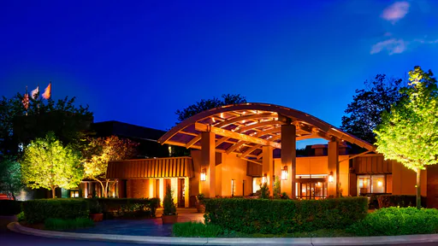

Registration Link:
https://www.marriott.com/event-reservations/reservation-link.mi?id=1736971865811&key=GRP&guestreslink2=true&app=resvlink

State Government rate of $102.00 Traditional Room, Two Beds, Double Occupancy.

Conference Registration:

Registration Fee for conference is $265.00, which includes two lunches.

Discounts are offered for teams sending ten (10) or more officers. Please contact Steve Pederson for details:

spederson94@gmail.com or 262-309-2911

